XOR-Hex Based Encryption and Decryption System

1. Title Page
- Project Title: XOR-Hex Based Encryption and Decryption System
- Student Name: Arun kannan.R
- Register Number: 921724115007
- Department: Computer Science and Design
- College Name: Sethu Institute of Technology
- Course: Programming in C
- Guide / Trainer Name: Balaji
- Submission Date: February 26, 2026

2. Abstract
The XOR-Hex Cipher project is a security-focused utility designed to protect sensitive text data through symmetric-key cryptography. The program utilizes bitwise XOR (Exclusive OR) operations to transform standard plaintext into a secure hexadecimal format. By employing a user-defined secret key, the system ensures that data can only be reverted to its original form by an authorized user possessing the same key. This project demonstrates the practical application of low-level data manipulation and memory management in the C language.

3. Introduction

Problem Statement: Communication in a digital environment is susceptible to unauthorized access. Storing or sending raw text (plaintext) poses a significant security risk.
Utility: This project provides a lightweight method to obfuscate text, making it unreadable to anyone without the specific cryptographic key.
Use Cases: It can be used for secure personal note-taking, local storage of sensitive credentials, and as a foundational tool for learning cryptographic principles.

4. Objectives
Understand Structured Programming: Organizing code into modular functions for encryption and decryption.
Use Loops and Conditions: Implementing iterative bitwise processing and menu-driven user control.
Work with Arrays and Functions: Managing character arrays (strings) and passing them as pointers to specialized logic blocks.
Improve Logical Thinking: Mapping ASCII characters to hexadecimal values and handling modular arithmetic for key repetition.

5. Tools & Technology
Programming Language: C (C99/C11 Standard)
Compiler: GCC (GNU Compiler Collection)
Platform: Windows / Linux / macOS

6. System Requirements
Hardware: Basic computing system with minimum 4GB RAM and 100MB of available disk space.
Software: A C compiler (GCC recommended) and a Text Editor (VS Code, Sublime Text) or IDE (Code::Blocks).

7. Methodology / Algorithm
Start: Initialize the program and prompt for a secret key.
Key Entry: Store the key in a character array to be used as the XOR mask.
Menu Display: Offer the user two options: (1) Encrypt Text or (2) Decrypt Hex.
Encryption Logic:
- Read plaintext string.
- Iterate through each character.
- Apply XOR: $CipherChar = PlainChar \oplus Key[i \pmod{KeyLength}]$.
- Output the result as a two-digit Hexadecimal value.
Decryption Logic:
- Read hexadecimal pairs.
- Convert Hex to an integer.
- Apply XOR: $PlainChar = CipherInt \oplus Key[i \pmod{KeyLength}]$.
- Output the result as a standard Character.
End: Terminate the program execution.

8. Flowchart

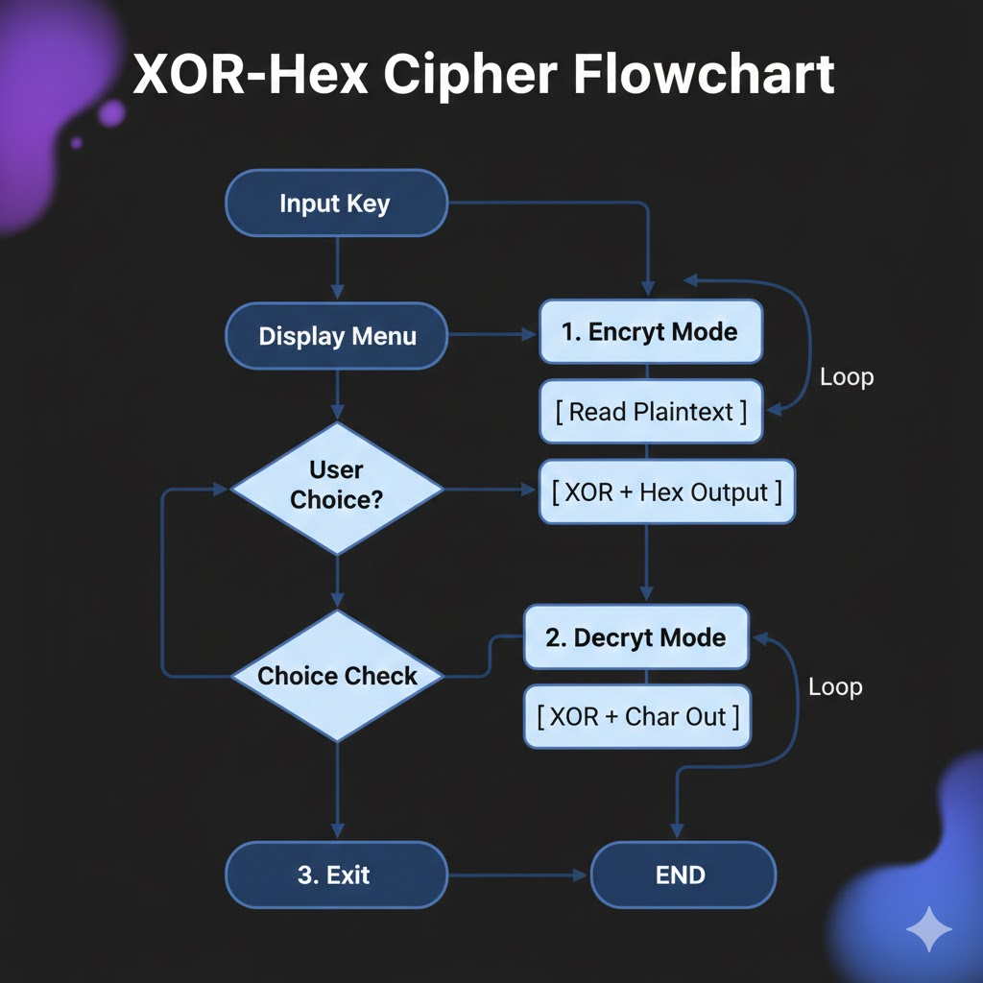

9. Program Code
#include <stdio.h>
#include <string.h>

void encrypt_mode(char *key) {
char text[200];
int key_len = strlen(key);

printf("Enter plain text to encrypt: ");
getchar(); // Clear the buffer
fgets(text, sizeof(text), stdin);

printf("Encrypted (Hex Code): ");
for (int i = 0; text[i] != '\n' && text[i] != '\0'; i++) {
// Perform XOR and print as 2-digit Hex
printf("%02x ", (unsigned char)(text[i] ^ key[i % key_len]));
}
printf("\n");
}

void decrypt_mode(char *key) {
unsigned int hex_val;
int key_len = strlen(key);
int i = 0;

printf("Enter Hex codes (e.g., 1a 0f 22) and type '00' to finish:\n");

printf("Decrypted Text: ");
while (scanf("%x", &hex_val) && hex_val != 0) {
// Perform XOR on the hex value and print as character
printf("%c", (char)(hex_val ^ key[i % key_len]));
i++;
}
printf("\n");
}

int main() {
int choice;
char key[50];

printf("--- Text Vault: Hex Edition ---\n");
printf("Enter secret password: ");
scanf("%s", key);

printf("1. Encrypt Text -> Hex\n");
printf("2. Decrypt Hex -> Text\n");
printf("Choice: ");
scanf("%d", &choice);

if (choice == 1) {
encrypt_mode(key);
} else if (choice == 2) {
decrypt_mode(key);
} else {
printf("Invalid choice!\n");
}

return 0;
}

10. Sample Input / Output
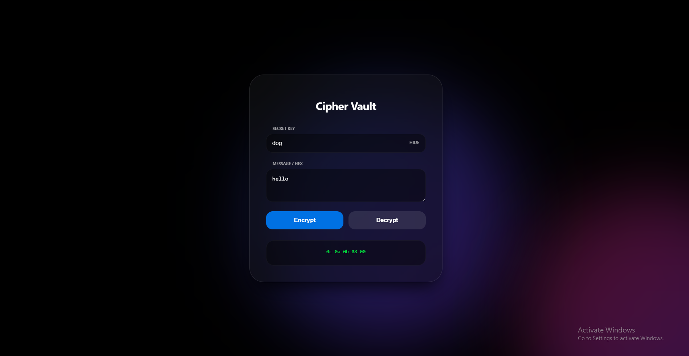
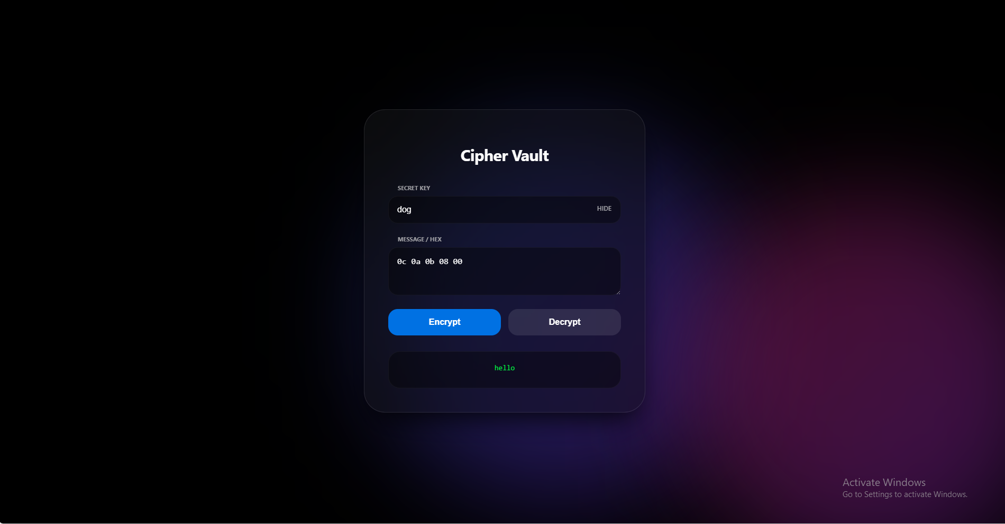

11. Result
The program executed successfully. It accurately converted plaintext into hexadecimal strings and successfully restored the original text when the correct key was provided in decryption mode.

12. Applications
Learning Programming: Practical application of bitwise operators and ASCII/Hex conversion.
Academic Practice: Demonstrates competence in string handling and modular code design.
Beginner Software Development: Acts as a base-level security module for larger software applications.

13. Conclusion
The project effectively demonstrates how bitwise logic can be used to create functional security software. It highlights the power of the C language in performing low-level data transformations and provides a robust foundation for understanding symmetric encryption.

14. Future Enhancements
File Handling: Enable the program to read from and write directly to .txt files.
Advanced UI: Develop a graphical user interface (GUI) or a web-based front end.
Extended Features: Implement multi-layer encryption or integration with standard libraries like OpenSSL.

15. References
Learning Programming: Practical application of bitwise operators and ASCII/Hex conversion.
Academic Practice: Demonstrates competence in string handling and modular code design.
Beginner Software Development: Acts as a base-level security module for larger software applications.

